

Semester Two Examination, 2022
Question/Answer booklet

MATHEMATICS
SPECIALIST
UNITS 3&4

SOLUTIONS
Section Two:
Calculator-assumed
WA student number: In figures

In words

Your name
Number of additional
answer booklets used
(if applicable):

Time allowed for this section
Reading time before commencing work: ten minutes
Working time: one hundred minutes

Materials required/recommended for this section
To be provided by the supervisor
This Question/Answer booklet
Formula sheet (retained from Section One)

To be provided by the candidate
Standard items: pens (blue/black preferred), pencils (including coloured), sharpener,
correction fluid/tape, eraser, ruler, highlighters

Special items: drawing instruments, templates, notes on two unfolded sheets of A4 paper, and up to three calculators, which can include scientific, graphic and Computer Algebra System (CAS) calculators, are permitted in this ATAR course examination

Important note to candidates
No other items may be taken into the examination room. It is your responsibility to ensure that you do not have any unauthorised material. If you have any unauthorised material with you, hand it to the supervisor before reading any further.

Structure of this paper

Section | Number of  questions  available | Number of  questions to  be answered | Working  time  (minutes) | Marks  available | Percentage  of  examination
Section One:  Calculator-free | 7 | 7 | 50 | 49 | 35
Section Two:  Calculator-assumed | 12 | 12 | 100 | 91 | 65
 |  |  |  | Total | 100

Instructions to candidates

1. The rules for the conduct of examinations are detailed in the school handbook. Sitting this examination implies that you agree to abide by these rules.

2. Write your answers in this Question/Answer booklet preferably using a blue/black pen.
Do not use erasable or gel pens.

3. You must be careful to confine your answers to the specific question asked and to follow any instructions that are specific to a particular question.

4. Show all your working clearly. Your working should be in sufficient detail to allow your answers to be checked readily and for marks to be awarded for reasoning. Incorrect answers given without supporting reasoning cannot be allocated any marks. For any question or part question worth more than two marks, valid working or justification is required to receive full marks. If you repeat any question, ensure that you cancel the answer you do not wish to have marked.

5. It is recommended that you do not use pencil, except in diagrams.

6. Supplementary pages for planning/continuing your answers to questions are provided at the end of this Question/Answer booklet. If you use these pages to continue an answer, indicate at the original answer where the answer is continued, i.e. give the page number.

7. The Formula sheet is not to be handed in with your Question/Answer booklet.
Section Two: Calculator-assumed 65% (91 Marks)
This section has twelve questions. Answer all questions. Write your answers in the spaces provided.

Working time: 100 minutes.

Question 8 (8 marks)
The distribution of the weights $W$ of loaves of rye bread produced by a bakery has a mean and standard deviation of $735$ g and $15$ g respectively. Quality control frequently take random samples of $60$ white loaves from the bakery and calculate the mean weight of each sample.

(a) Describe the expected distribution of these sample means. (3 marks)
Solution
$$s=15÷\sqrt{60}=1.9365$$
Sample means will be normally distributed with a mean of $735$ g and standard deviation of $1.9365$ g.

Specific behaviours
states normally distributed
ü states mean
ü calculations standard deviation

Further production checks are made if the mean weight of a sample is less than a prescribed minimum value of $731.3$ g.

(b) Over the course of the next $250$ random samples, how many times would you expect that further production checks need to be made? (2 marks)
Solution
$$P\left(\overline{W}<731.3\right)=0.0280$$

Hence, expect to make further checks $250×0.028=7$ times.

Specific behaviours
calculates probability
ü calculates expected number of times

Quality control has to reduce the sample size from $60$ to $49$ and change the prescribed minimum value so that the frequency of further production checks remains the same.

(c) Determine the prescribed minimum value for the mean weight of a sample required for this change. (3 marks)
Solution
New standard deviation of sampling distribution will be $s=15÷\sqrt{49}=2.1429$.

Required $z$-score for $p=0.028$ is $z=-1.911$.
Hence
$$\frac{w-735}{2.1429}=-1.911⇒w=730.9$$

The prescribed minimum value should be changed to $730.9$ g.

Specific behaviours
calculations new standard deviation
ü obtains $z$-score for required probability
ü calculates required value

Question 9 (6 marks)
The position vectors of points $A$ and $B$ are $\left(\begin{matrix}2 \\ 7\end{matrix}\right)$ and $\left(\begin{matrix}6 \\ -1\end{matrix}\right)$ respectively.

(a) Determine the vector equation of line $L$ that passes through $A$ and $B$. (1 mark)
Solution
$$\vec{AB}=\left(\begin{matrix}6 \\ -1\end{matrix}\right)-\left(\begin{matrix}2 \\ 7\end{matrix}\right)=\left(\begin{matrix}4 \\ -8\end{matrix}\right)=4\left(\begin{matrix}1 \\ -2\end{matrix}\right)$$

$$r=\left(\begin{matrix}2 \\ 7\end{matrix}\right)+λ\left(\begin{matrix}1 \\ -2\end{matrix}\right)$$

Specific behaviours
ü correct vector equation

The vector equation of curve $S$ is $r=\left(\begin{matrix}2μ+3 \\ 4-4μ^{2}\end{matrix}\right)$.

(b) Determine the Cartesian equation of curve $S$. (2 marks)
Solution
$$x=2μ+3→μ=\frac{x-3}{2}$$

$$y=4-4{\left(\frac{x-3}{2}\right)}^{2} \\ y=-x^{2}+6x-5$$

Specific behaviours
expresses $μ$ in terms of $x$ or $y$
ü obtains Cartesian equation (any form)

(c) Determine the position vector(s) of the point(s) where curve $S$ meets line $L$. (3 marks)
Solution
Equating coefficients:
$$2+λ=2μ+3 \\ 7-2λ=4-4μ^{2}$$

Solving simultaneously gives $μ=\frac{1}{2}, λ=2$.

$$\left(\begin{matrix}2 \\ 7\end{matrix}\right)+2\left(\begin{matrix}1 \\ -2\end{matrix}\right)=\left(\begin{matrix}4 \\ 3\end{matrix}\right)$$

Hence position vector of point is $\left(\begin{matrix}4 \\ 3\end{matrix}\right)$.

Specific behaviours
forms simultaneous equations
ü solves equations for $λ$ and/or $μ$
ü substitutes to obtain correct position vector

Question 10 (9 marks)
Let $f\left(x\right)=\ln\left(5-\sqrt{x+4}\right)$ and $g\left(x\right)=x^{2}-4x$.

(a) State the domain and range of $f$. (3 marks)
Solution
For natural domain we require $5-\sqrt{x+4}>0$.
Hence $x+4≥0⇒x≥-4$ and $\sqrt{x+4}<5⇒x<21$.

$$D_{f}=\left\{x \right| x∈R, -4≤x<21\}$$

Range will be all values of $\ln{k}$ where $0<k≤5$. Hence

$$R_{f}=\left\{y \right| y∈R ,y≤\ln{5}\}$$

Specific behaviours
indicates at least one required condition / inequality
ü correct domain
ü correct range

(b) Determine $f^{-1}\left(x\right)$ and state its range. (3 marks)
Solution
$$x=\ln\left(5-\sqrt{y+4}\right) \\ e^{x}=5-\sqrt{y+4} \\ y={\left(5-e^{x}\right)}^{2}-4 \\ f^{-1}\left(x\right)=e^{2x}-10e^{x}+21$$

$$R_{f^{-1}}=D_{f}=\left\{x \right| x∈R, -4≤x<21\}$$

Specific behaviours
indicates appropriate steps to obtain inverse
ü correct inverse (factored or expanded form)
ü correct range

(c) Determine an expression for $f∘g(x)$ and state the domain for which the composite function is defined. (3 marks)
Solution
$$f∘g\left(x\right)=\ln\left(5-\sqrt{x^{2}-4x+4}\right) \\ =\ln\left(5-|x-2|\right)$$

For the domain we require $5-\left|x-2\right|>0⇒-3<x<7.$

$$D_{f∘g}=\left\{x \right| x∈R, -3<x<7\}$$

Specific behaviours
correct expression for composite function
ü indicates required condition
ü correct domain

Question 11 (6 marks)
The position vector of a particle moving in the Cartesian plane at time $t$ seconds is given by

$$r\left(t\right)=-7\cos\left(2t\right)i+7\sin\left(2t\right)j.$$

(a) Show that the particle is moving at a constant speed. (2 marks)
Solution
Velocity:
$$v\left(t\right)=\frac{d}{dt}\left(r\left(t\right)\right)=14\sin\left(2t\right)i+14\cos\left(2t\right)j.$$
Speed:
$$\left|v\left(t\right)\right|=14\sqrt{{\left(\sin\left(2t\right)\right)}^{2}+{\left(\cos\left(2t\right)\right)}^{2}} \\ =14×1 \\ =14$$

Specific behaviours
differentiates to obtain velocity vector
ü uses Pythagorean identity to show speed is constant

(b) Calculate the scalar product of the position vector and the velocity vector of the particle and interpret the result. (2 marks)
Solution
$$r\left(t\right)∙v\left(t\right)=\left(\begin{matrix}-7\cos\left(2t\right) \\ 7\sin\left(2t\right)\end{matrix}\right)∙\left(\begin{matrix}14\sin\left(2t\right) \\ 14\cos\left(2t\right)\end{matrix}\right) \\ =98\cos\left(2t\right)\sin\left(2t\right)-98\cos\left(2t\right)\sin\left(2t\right) \\ =0$$

Hence the position vector and the velocity vector of the particle are always perpendicular.

Specific behaviours
calculates scalar product
ü interprets result of scalar product

(c) Determine the acceleration vector of the particle when its position vector is $-7j$. (2 marks)
Solution
$$a\left(t\right)=\frac{d}{dt}\left(v\left(t\right)\right) \\ =28\cos\left(2t\right)i-28\sin\left(2t\right)j \\ =-4 r(t)$$

Hence $a=-4×-7j=28j$.

Specific behaviours
differentiates to obtain acceleration vector
ü correct acceleration vector at given position

Question 12 (9 marks)
The mean and standard deviation of a random sample of $52$ physics teachers working in a region was $45.2$ and $6.4$ years respectively. The sample was taken to construct a confidence interval for the mean age of such teachers.

(a) State two reasons why it is appropriate to assume the approximate normality of the distribution of the sample mean for this data. (2 marks)
Solution
Sampling is random and sample size of $52$ is large (i.e., exceeds $30$).

Specific behaviours
states sampling is random
ü states sample size is large

(b) State another assumption required to construct a valid confidence interval. (1 mark)
Solution
- sample standard deviation is a good estimate for the population standard deviation.
- sample values are independent of each other

Specific behaviours
states one valid assumption

(c) Construct a $90\%$ confidence interval for the mean age of physics teachers working in the region. (3 marks)
Solution
$$s=6.4÷\sqrt{52}=0.8875, z_{0.90}=1.645$$
Interval:
$$45.2-1.645\left(0.8875\right)≤μ≤45.2+1.645\left(0.8875\right)$$
$$45.2-1.46≤μ≤45.2+1.46$$

$$43.74≤μ≤46.66$$

Specific behaviours
standard deviation of sampling distribution
ü correct expression for confidence interval
ü correct confidence interval

(d) Based on another random sample, the $99\%$ confidence interval for the mean age of art teachers employed in the same region was calculated to be $(39.09, 44.71)$. Given that the standard deviation of the sample was $6.9$ years, determine the size of the sample.
(3 marks)
Solution
$$z_{0.99}=2.576$$
$$E=\left(44.71-39.09\right)÷2=2.81$$

$$n={\left(\frac{2.576×6.9}{2.81}\right)}^{2}=40$$

Specific behaviours
margin of error $E$
ü correct equation for sample size
ü correct sample size $n$

Question 13 (8 marks)
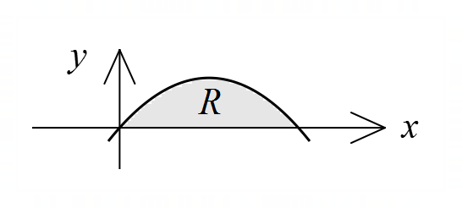
Let $f\left(x\right)=x(a-x)$, where $a$ is a constant, and region $R$
be the area between the $x$-axis and the curve $y=f(x)$.
All dimensions are in centimetres.

(a) When $a=18$, determine the volume of revolution when $R$ is rotated about the $y$-axis.
(5 marks)
Solution
Expressions for inner and outer curves:
$$y=x\left(18-x\right)⇒x=9±\sqrt{81-y}$$

When $x=18÷2, y_{max}=81$.

$$V_{O}=π\int_{0}^{81}{{\left(9+\sqrt{81-y}\right)}^{2}}dy \left(=\frac{37179π}{2}≈58401\right)$$
$$V_{I}=π\int_{0}^{81}{{\left(9-\sqrt{81-y}\right)}^{2}}dy \left(=\frac{2187π}{2}≈3435\right)$$

$$V=V_{O}-V_{I} \\ =π\int_{0}^{81}{36\sqrt{81-y}}dy \\ =17 496π≈54 965 {\text{cm}}^{3}$$

Specific behaviours
expressions for inner and outer curves
ü obtains maximum value of $y$
ü indicates correct definite integral for inner or outer volume
ü indicates appropriate method to obtain required volume
ü obtains correct volume

(b) When $R$ is rotated about the $x$-axis, the volume of revolution is $\begin{matrix}81π \\ \overline{ 10 }\end{matrix}$ cm³.
Determine the value of $a$. (3 marks)
Solution
$$V=π\int_{0}^{a}{{\left(x\left(a-x\right)\right)}^{2}} dx \\ =\frac{a^{5}π}{30}$$

$$\frac{a^{5}π}{30}=\frac{81π}{10} \\ a=3$$

Specific behaviours
ü correct definite integral for volume
ü obtains expression for volume in terms of $a$
forms equation and solves for $a$

Question 14 (8 marks)
Consider the complex number $z$.

(a) Let $R$ be the subset of the complex plane that satisfies $\left|z+1\right|≥|z-1+4i|$.

(i) Sketch the subset $R$. (3 marks)

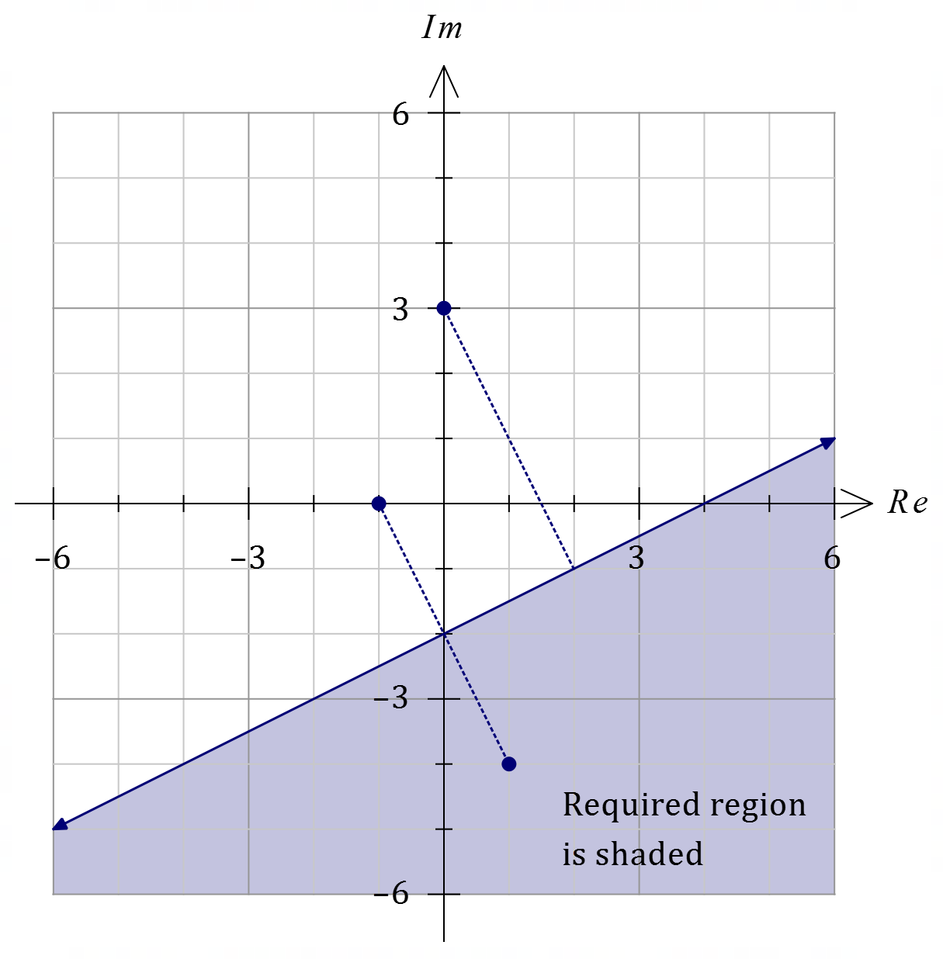
Solution
$R: \left|z-\left(-1+0i\right)\right|≥|z-\left(1-4i\right)|$.
See diagram.
Specific behaviours
indicates two given points
ü draws their perpendicular bisector
ü indicates correct side of line

(ii) Determine the exact minimum value of $|z-3i|$ in $R$. (2 marks)

Solution
Require minimum distance from $R$ to $3i$.

$$d=2\sqrt{1^{2}+2^{2}}=2\sqrt{5} \text{units}$$

Specific behaviours
indicates value as distance
ü correctly calculates distance

(b) Sketch the subset of the complex plane that satisfies the equation $\arg\left(\begin{matrix}z+i \\ \overline{z+1}\end{matrix}\right)=±π$.
(3 marks)
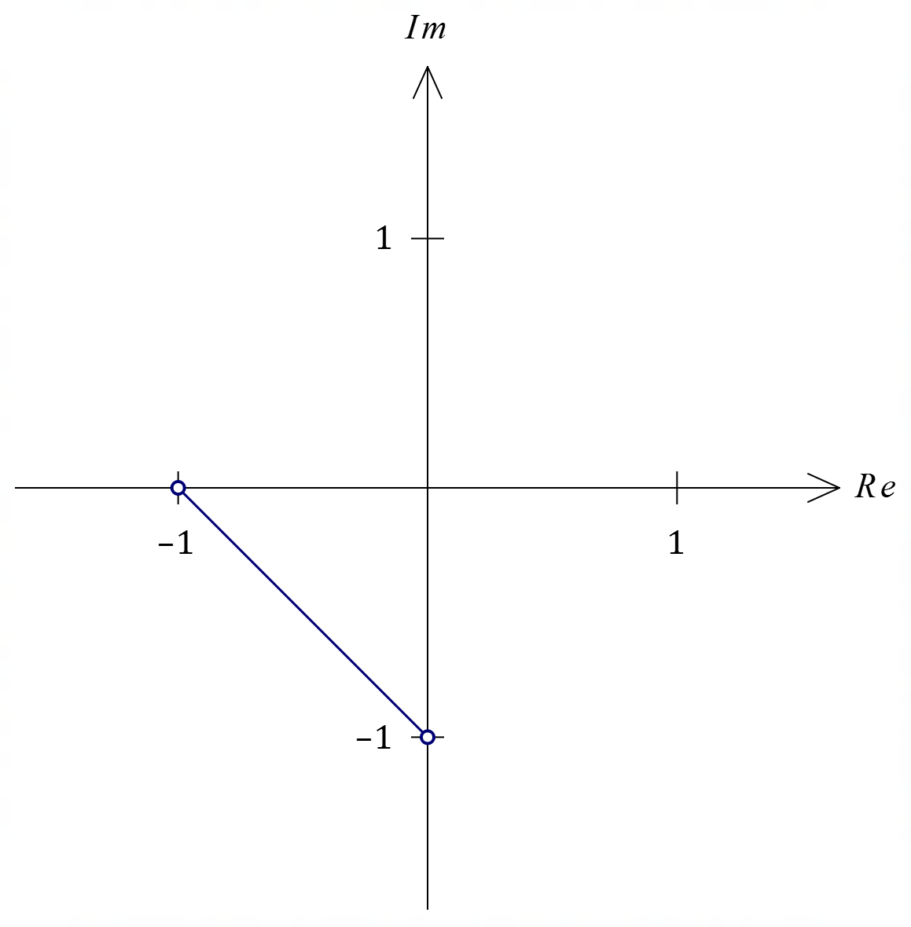
Solution
$$\arg\left(\frac{z+i}{z+1}\right)=±π⇒\arg\left(z+i\right)-\arg\left(z+1\right)=±π$$
Arguments of $z$ from $-i$ and $-1$ must be opposite.

Specific behaviours
indicates arguments from $-i$ and $-1$ opposite
ü correct rays in complex plane
ü indicates ray ends not included

Question 15 (7 marks)
Let $OABC$ be a rectangle in the complex plane, where $O$ is the origin. The points $A$ and $C$ represent the complex numbers $z$ and $-\sqrt{3}iz$ respectively, where $Re\left(z\right)<0$ and $Im\left(z\right)>0$.

(a) Draw a labelled sketch of the rectangle in the complex plane. (2 marks)

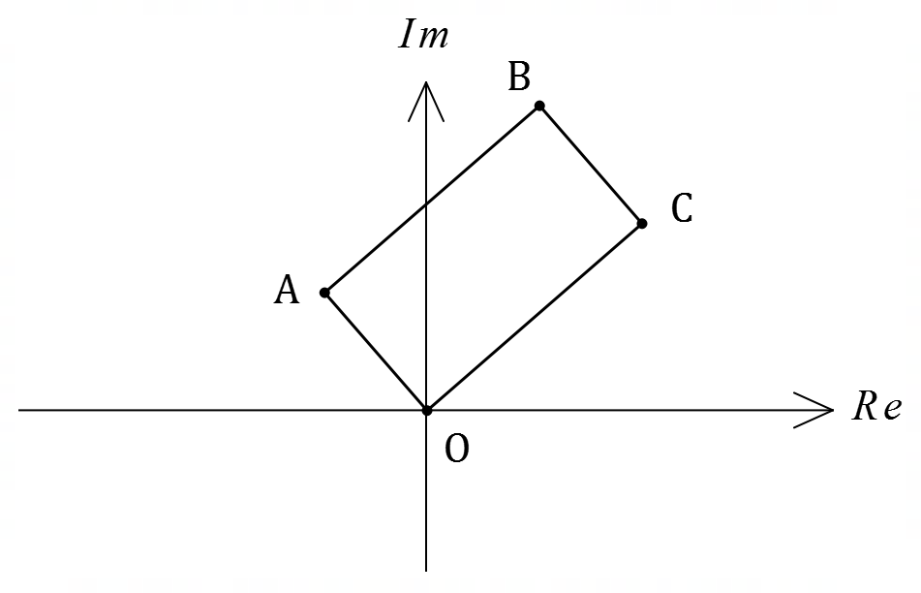
Solution
See diagram
Specific behaviours
rectangle, $A$ in second quadrant
ü $C$ in first quadrant, $∠AOC≈90°$

(b) Determine the complex number represented by $B$. (1 mark)
Solution
$$B=z+\left(-\sqrt{3}i\right)z \\ =\left(1-\sqrt{3}i\right)z$$

Specific behaviours
ü correct complex number for $B$

Rectangle $OABC$ is rotated $120°$ about $O$ in an anticlockwise direction to $OA'B'C'$.

(c) Determine in exact Cartesian form the complex numbers represented by the points $A^{'}, B'$ and $C'$. (4 marks)
Solution
Let $w=\operatorname{cis}\left(120°\right)=-\frac{1}{2}+\frac{\sqrt{3}}{2}i$ so that multiplying any complex number by $w$ will rotate it $120°$ anticlockwise in the complex plane. Then

$$A^{'}=\left(-\frac{1}{2}+\frac{\sqrt{3}}{2}i\right)z, C^{'}=\left(-\frac{1}{2}+\frac{\sqrt{3}}{2}i\right)\left(-\sqrt{3}iz\right)=\left(\frac{3}{2}+\frac{\sqrt{3}}{2}i\right)z$$

$$B^{'}=\left(-\frac{1}{2}+\frac{\sqrt{3}}{2}i\right)\left(1-\sqrt{3}i\right)z=\left(1+\sqrt{3}i\right)z$$

Specific behaviours
indicates use of multiplication by complex number for rotation
ü complex number for $A^{'}$
ü simplified complex number for $C'$
ü simplified complex number for $B'$

Question 16 (8 marks)
The probability $P$ that an adult King Charles spaniel of weight $w$ kg is a female can be modelled by the logistic equation
$$P=\frac{1}{1+0.000 006e^{2.1w}} .$$

(a) Calculate the probability that a spaniel of weight $5.8$ kg is a female. (1 mark)
Solution
$$P=0.461$$
Specific behaviours
correct value

(b) Sketch the graph of this model on the axes below. (2 marks)
Solution
See graph
Specific behaviours
endpoints and logistic 'S' curve
ü point of inflection close to $(5.7, 0.5)$

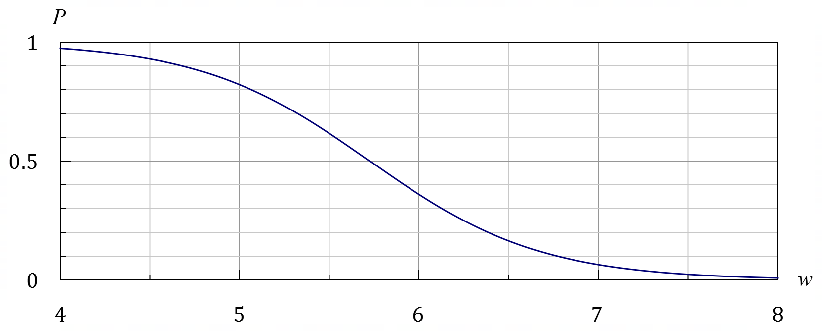

(c) The logistic equation can be written in the form $\begin{matrix}dP \\ \overline{dw}\end{matrix}=rP(k-P)$. State the value of $r$ and the value of $k$. (2 marks)
Solution
$k$ is limiting value as $w→-∞$ and so $k=1$.

From defining rule, $-rk=2.1⇒r=-2.1$.

Specific behaviours
value of $k$
ü value of $r$

(d) The sensitivity $S$ of the model is defined as the absolute value of the change in $P$ for a one-gram increase in the weight of a spaniel. Determine the maximum value of $S$.
(3 marks)
Solution
$P$ changing fastest at point of inflection, when $P=0.5$.

$$\frac{dP}{dw}=-2.1\left(0.5\right)\left(1-0.5\right)=-0.525 \text{units/kg}$$

This rate is in kg, hence $S_{MAX}=0.525÷1000=0.000 525 \text{u/g}$.

Specific behaviours
indicates where the rate of change is greatest
ü obtains value of $\frac{dp}{dw}$ at point of inflection
ü correct maximum value of $S$

Question 17 (7 marks)
(a) Let the complex numbers $z=r\operatorname{cis}{θ}$ and $w=\begin{matrix}\sqrt{3}+i \\ \overline{ 3z }\end{matrix}$. Determine the modulus and argument of $w$ in terms of the real constants $r$ and $θ$.
(2 marks)
Solution
$$w=\frac{\sqrt{3}+i}{3z}=\frac{2\operatorname{cis}\left(\frac{π}{6}\right)}{3r\operatorname{cis}{θ}}=\frac{2}{3r}\operatorname{cis}\left(\frac{π}{6}-θ\right)$$

Hence $\left|w\right|=\begin{matrix}2 \\ \overline{3r}\end{matrix}$ and $\arg\left(w\right)=\begin{matrix}π \\ \overline{6}\end{matrix}-θ$.

Specific behaviours
modulus
ü argument

(b) Let the complex numbers $z=3+ai$ and $w=\begin{matrix}z-5 \\ \overline{z+1}\end{matrix}$. Determine the value(s) of the real constant $a$ given that $w$ is purely imaginary. (2 marks)
Solution
$$w=\frac{-2+ai}{4+ai}=\frac{a^{2}-8}{a^{2}+16}+\frac{6a}{a^{2}+16}i$$

$Re\left(w\right)=0⇒a^{2}-8=0⇒a=±2\sqrt{2}$.

Specific behaviours
expresses $w$ in real and imaginary parts
ü correct values of $a$

(c) The complex number $w=6\operatorname{cis}\left(\begin{matrix}8π \\ \overline{17}\end{matrix}\right)$ is a root of the equation $z^{n}-(x+y i)=0$,
where $n, x$ and $y$ are real non-zero constants.
Determine two roots of the complex equation $z^{2n}-(x+y i)=0$. (3 marks)
Solution
${z^{2n}=\left(z^{2}\right)}^{n}=x+yi⇒z^{2}=w$ is a solution, so require square roots of $6\operatorname{cis}\left(\begin{matrix}8π \\ \overline{17}\end{matrix}\right)$.

$$z_{n}=\sqrt{6}\operatorname{cis}\left(\frac{8π}{17×2}-\frac{2nπ}{2}\right), n=0, 1$$

$$z_{0}=\sqrt{6}\operatorname{cis}\left(\frac{4π}{17}\right), z_{1}=\sqrt{6}\operatorname{cis}\left(-\frac{13π}{17}\right)$$

Specific behaviours
indicates square roots of $w$ required
ü one root
ü second root

Question 18 (7 marks)
A small body is moving in a straight line so that $t$ seconds after leaving fixed point $O$ its velocity is $v$ cm/s and its acceleration $a=b v+c$ cm/s², where $b$ and $c$ are constants.

Initially the body is at rest at $O$ and its acceleration is $3.6$ cm/s².

$T$ seconds later, its velocity is $4$ m/s and its acceleration is $0.4$ m/s².

(a) Show that $5 \begin{matrix}dv \\ \overline{dt}\end{matrix}+4v-18=0$. (3 marks)
Solution
When $t=0, v=0, a=3.6$ and when $t=T, v=5, a=-0.4$. Using $a=bv+c$:
$$3.6=b\left(0\right)+c⇒c=3.6 \\ 0.4=4b+3.6⇒b=-0.8$$
Hence
$$a=-0.8v+3.6 \\ 5a=-4v+18 \\ 5\frac{dv}{dt}+4v-18=0$$

Specific behaviours
obtains value of $c$
ü obtains value of $b$
ü uses $a=\frac{dv}{dt}$ to obtain equation

(b) Determine the exact value of $T$. (4 marks)
Solution
$$\frac{dv}{dt}=\frac{18-4v}{5} \\ \int{\frac{dv}{18-4v}}=\int{\frac{dt}{5}} \\ -\frac{1}{4}ln\left|18-4v\right|=\frac{t}{5}+C$$
When $t=0, v=0$ and so
$$C=-\frac{1}{4}\ln{18}$$
When $t=T, v=4$ and so
$$\frac{T}{5}=\frac{1}{4}\ln{18}-\frac{1}{4}\ln{2} \\ T=\frac{5}{4}\ln{9} \\ =\frac{5}{2}\ln{3}\text{s} (≈2.75 \text{s})$$

Specific behaviours
separates variables
ü obtains correct antiderivative
ü evaluates constant of integration
ü obtains exact value of $T$

Question 19 (8 marks)
Plane $Π$ contains triangle $OAB$.
Relative to $O$, the points $A$ and $B$ have position vectors $a=\left(\begin{matrix}6 \\ -9 \\ -2\end{matrix}\right)$ and $b=\left(\begin{matrix}1 \\ -2 \\ 2\end{matrix}\right)$ respectively.

(a) State the unit vectors $\hat{a}$ and $\hat{b}$. (1 mark)
Solution
$$\hat{a}=\frac{1}{11}\left(\begin{matrix}6 \\ -9 \\ -2\end{matrix}\right), \hat{b}=\frac{1}{3}\left(\begin{matrix}1 \\ -2 \\ 2\end{matrix}\right)$$

Specific behaviours
correct unit vectors

(b) Calculate $∠AOB$. (1 mark)
Solution
$∠AOB$ is the angle between $\vec{OA}$ and $\vec{OB}$.

Using CAS, $∠AOB=\cos^{-1}\left(\frac{20}{33}\right)=52.7°$.

Specific behaviours
correct angle

(c) Determine the equation of plane $Π$ in the form $r∙n=k$. (2 marks)
Solution
$$n=a×b=\left(\begin{matrix}-22 \\ -14 \\ -3\end{matrix}\right)$$

Hence equation of plane is $r∙\left(\begin{matrix}22 \\ 14 \\ 3\end{matrix}\right)=0$.

Specific behaviours
indicates correct normal to plane
ü correct equation of plane (any multiple of $n$)

Point $C$ with position vector $xi+yj+zk$ lies in plane $Π$ and within triangle $OAB$ so that $\left|\vec{OC}\right|=1$ and $OC$ bisects $∠AOB$.

(d) Explain why the values of $x, y$ and $z$ must satisfy the equation $22x+14y+3z=0$.
(1 mark)
Solution
For $C$ to lie in plane, it must satisfy the equation for plane $Π$:

$$\left(\begin{matrix}x \\ y \\ z\end{matrix}\right)∙\left(\begin{matrix}22 \\ 14 \\ 3\end{matrix}\right)=0⇒22x+14y+3z=0$$

Specific behaviours
explains that $C$ lies in plane and so must satisfy equation from (c)

(d) Determine two other equations that the values of $x, y$ and $z$ must satisfy and hence, or otherwise, determine vector $\vec{OC}$, giving components rounded to three decimal places.
(3 marks)
Solution
So that $\left|\vec{OC}\right|=1$ (note that $\vec{OC}$ is a unit vector):

$$\left|\left(\begin{matrix}x \\ y \\ z\end{matrix}\right)\right|=1⇒x^{2}+y^{2}+z^{2}=1 …(1)$$

To have $∠AOC=∠COB,$ then $\hat{a}∙\vec{OC}=\vec{OC}∙\hat{b}$:

$$\frac{1}{11}\left(\begin{matrix}6 \\ -9 \\ -2\end{matrix}\right)∙\left(\begin{matrix}x \\ y \\ z\end{matrix}\right)=\frac{1}{3}\left(\begin{matrix}1 \\ -2 \\ 2\end{matrix}\right)∙\left(\begin{matrix}x \\ y \\ z\end{matrix}\right) \\ \frac{1}{11}\left(6x-9y-2z\right)=\frac{1}{3}\left(x-2y+2z\right) \\ 7x-5y-28z=0 …(2)$$

Solving equations $\left(1\right), (2)$ and from (d) simultaneously using CAS gives

$$\left(\begin{matrix}x \\ y \\ z\end{matrix}\right)=±\frac{\sqrt{3498}}{3498}\left(\begin{matrix}-29 \\ 49 \\ -8\end{matrix}\right)≈±\left(\begin{matrix}-0.490 \\ 0.828 \\ -0.271\end{matrix}\right)$$

So that $C$ lies in $ΔOAB$, $x>0$ and so

$$\left(\begin{matrix}x \\ y \\ z\end{matrix}\right)=\frac{\sqrt{3498}}{3498}\left(\begin{matrix}29 \\ -49 \\ 8\end{matrix}\right)≈\left(\begin{matrix}0.490 \\ -0.828 \\ 0.271\end{matrix}\right)$$

NB Other methods exist to determine $\vec{OC}$, such as finding point $P$ where the angle bisector intersects $AB$ and thus obtaining the required unit vector. Beware of erroneous arguments such as the angle bisector will bisect side $AB$, etc., but otherwise award one mark for an alternative approach that results in the correct vector. Note that $P\left({29}/{14}, -3.5, 8/7\right)$.
Specific behaviours
forms equation using magnitude of $\hat{c}$
ü forms equation so that $\vec{OC}$ is bisector (no simplification required)
ü obtains unit vector as required (3 d.p. for guidance only)

Supplementary page

Question number: _________

Supplementary page

Question number: _________

© 2022 WA Exam Papers. Perth Modern School has a non-exclusive licence to copy and communicate this document for non-commercial, educational use within the school. No other copying, communication or use is permitted without the express written permission of WA Exam Papers. SN078-204-4.

